Problem 1 [10 pts]: Practical applications of PVA analysis
Professor Wandke is designing a mechanism to launch a water balloon using linkage.
In Figure 1, the linkage has:
A=1m B= 0.6m C= 2.5m
Assume Professor Wandke accelerates at 1m/s², his slider moves at 3m/s and the slider is 1.2m away from point O4.
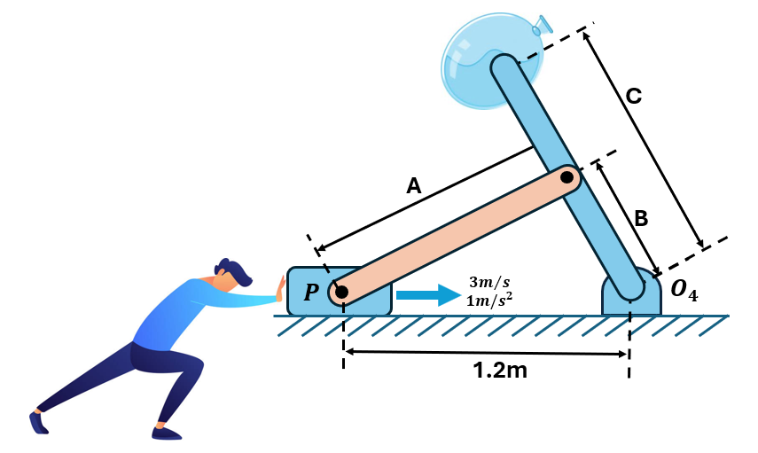
Figure 1. First Iteration Design

Perform a PVA analysis on Professor Wandke’s mechanism. Write out the vector loop equations for the position, velocity, and acceleration of the balloon. Compute the related link length, angles, angular velocities, and angular accelerations. State the linear velocity and acceleration of the balloon.

Problem 2 [15 pts]: 6 Bar mechanism PVA.
Professor Wandke decides to improve his design by adding another set of linkages onto it. What will the speed and acceleration of the balloon be now?
In Figure 2, the linkage has:
A= 1m B= 0.6m C=2.5m D=2.0m E= 2.5m F = 3.0m
G=1.5m
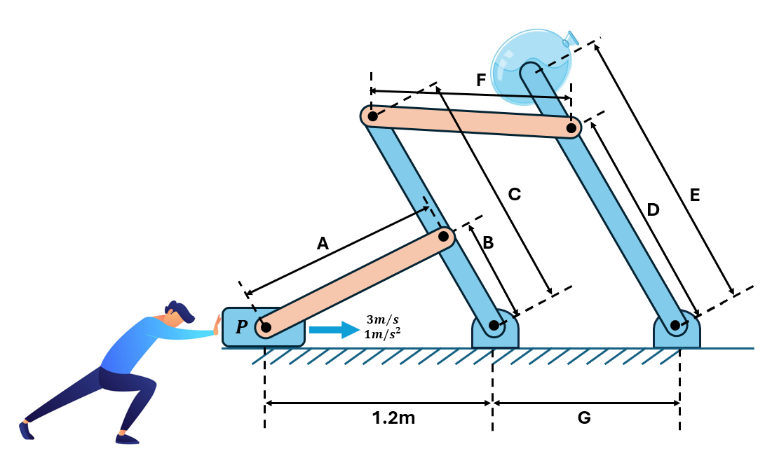
Figure 2. Second Iteration Design

Perform a PVA analysis on Professor Wandke’s mechanism. Write out the vector loop equations for the position, velocity, and acceleration of the balloon. Compute the related link length, angles, angular velocities, and angular accelerations. State the linear velocity and acceleration of the balloon.

Select one of the following options:
- My answer was created by a Gen AI algorithm, and I have not modified it
- My answer was created by a Gen AI algorithm, and I have made some minor changes.
- My answer was created by a Gen AI algorithm, and I have made major changes.
- My answer was created solely by myself.
- If I used Gen AI, I used ___ (name of program).

